PRODUCER GUIDE TO BEYONTEC
FOR MISSOURI FAIR PLAN

Table of Contents
GETTING STARTED 2
MY ACCOUNT 4
QUOTE ENTRY 8
CUSTOMER DETAIL PAGE – BASIC INFORMATION PAGE 9
PROPERTY DETAILS 11
COVERAGE 12
QUESTIONS 14
ADDITIONAL INFORMATION 15
ATTACHMENTS 16
ELECTRONIC SIGNATURE 20
SUBMIT APPLICATION 23
SINKHOLE 24
APPLICATIONS TAB 24
SEARCH TAB ON RIGHT 25
CLAIMS 25
QUERIES & REPORTS 26
CONTACT US 30

GETTING STARTED

- To start you will go to our website missourifairplan.com
- The Producers Guide can be found under Producers – Producer Summary and Manual – Scroll Down – Manual is available as PDF
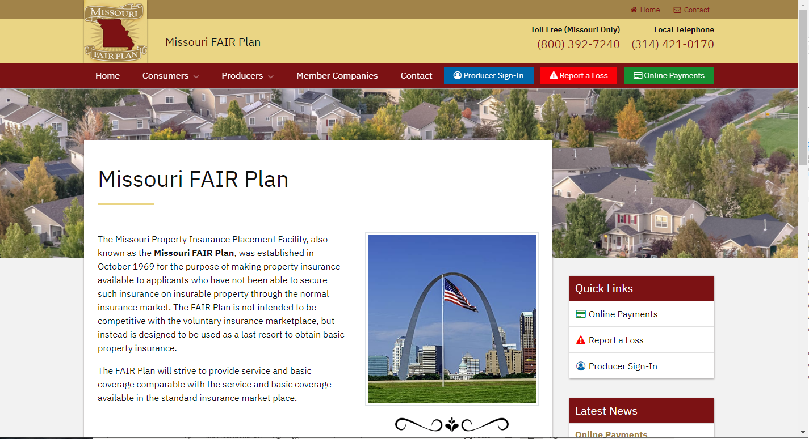
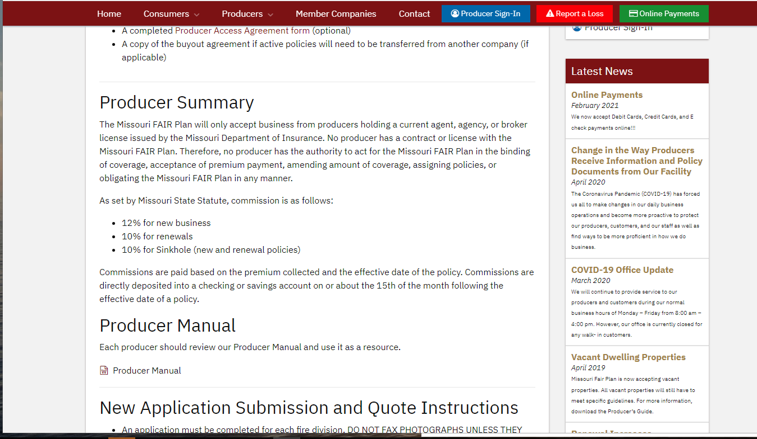

- Sign Into the Producer Portal is also available on our website
- At the top or right side of the page – click on link – Producer Sign In
- Log into Beyontec for Agents utilizing Google Chrome. Not all system functions work properly with EDGE.
- This system is Live. DO NOT USE PROGRAM FOR TESTING.
- Select Agent on the right side
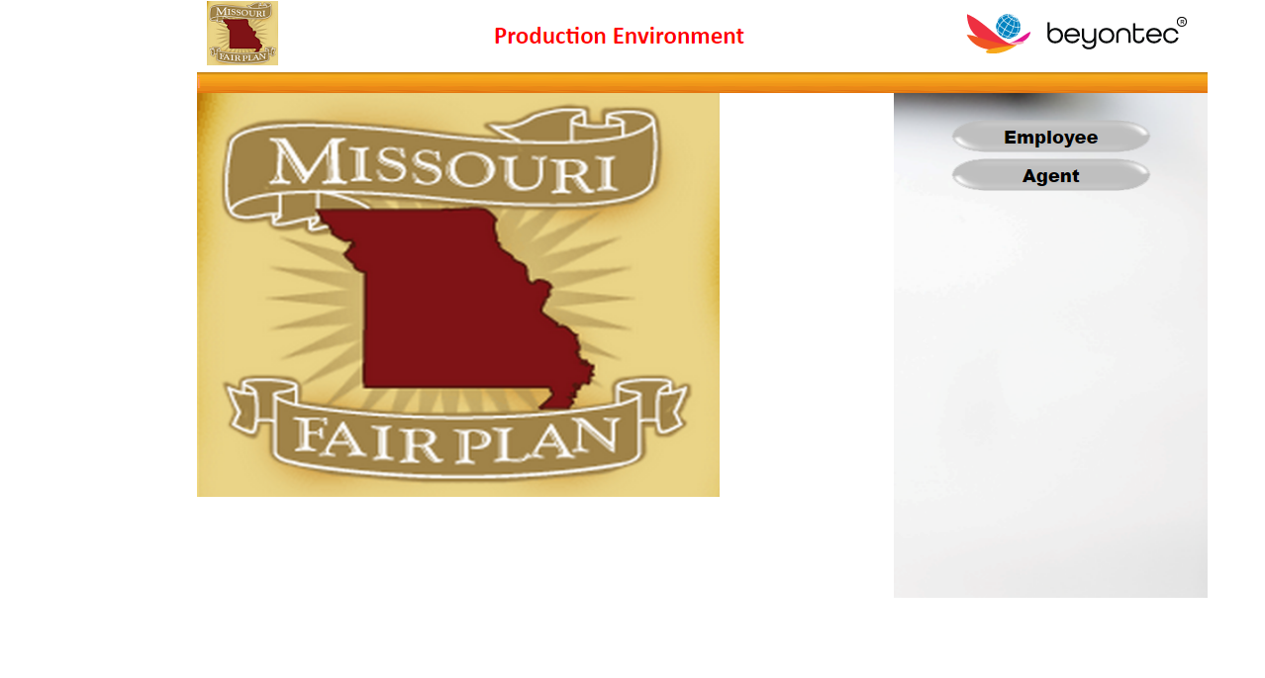
- Input your username and password that was provided by our facility. Only one login per agency account. Please contact us via email or phone if you do not remember your username and password. There is also a “change password" option available at the top of the page.
- Home page displays with My Transaction function tabs down the left and search on the right. A brief explanation of each is provided in the outline.
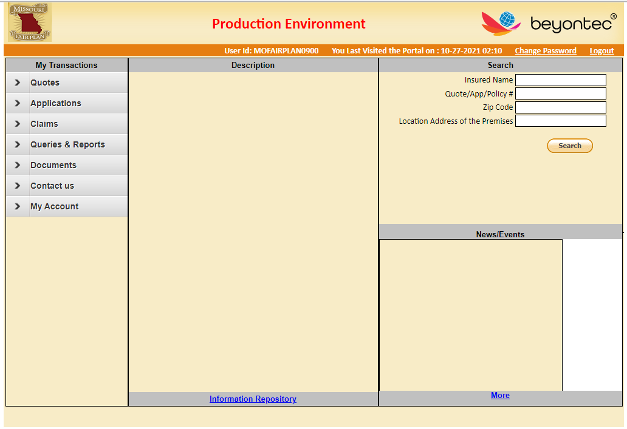

MY ACCOUNT
- My Account displays your agency information. Contact our office in writing to make changes. The agency CANNOT update this page even though there is an edit option available.
- Application Signature – Required to submit applications online – The words digital signature changes to view signature once this process has been completed.
  - Click on My Account
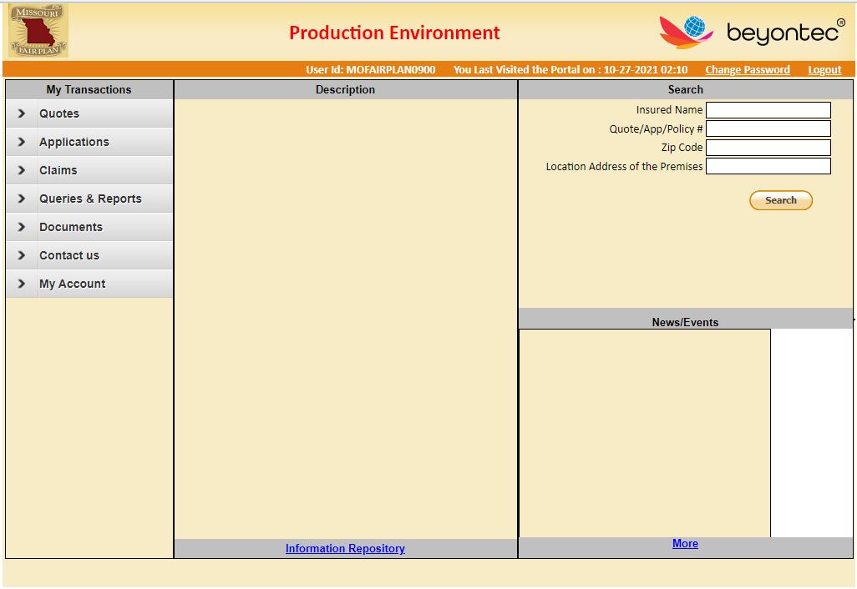
  - Click on Digital Signature
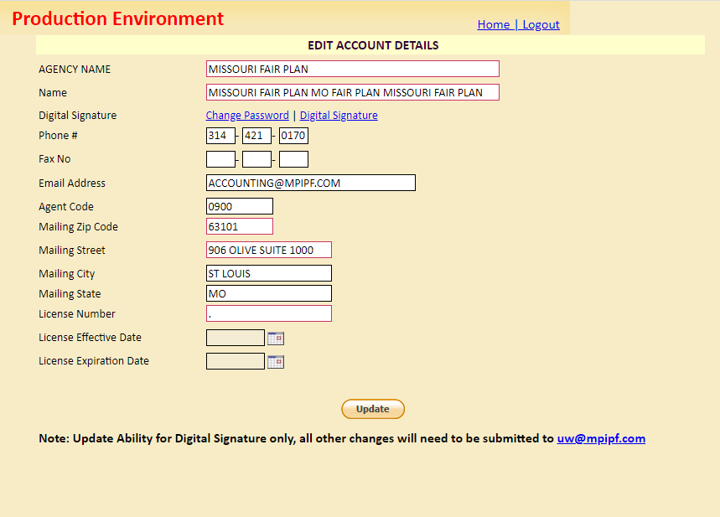
  - Complete the EZ-Sign Steps
    - Select Signature Style
    - Click Apply Signature Style
    - Click Green Error in Folder
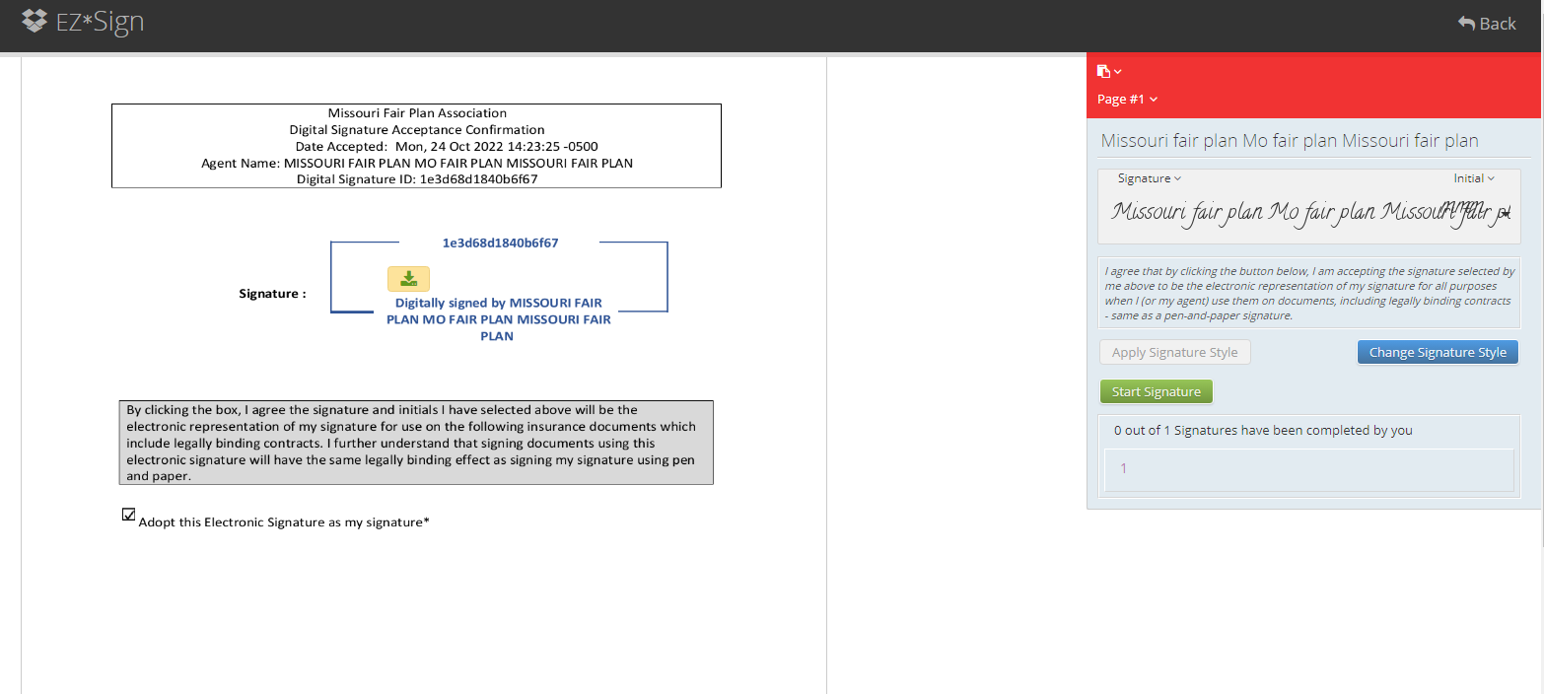
  - Switches from “Start Signature” to “Signing Complete”
  - Click on Signing Complete
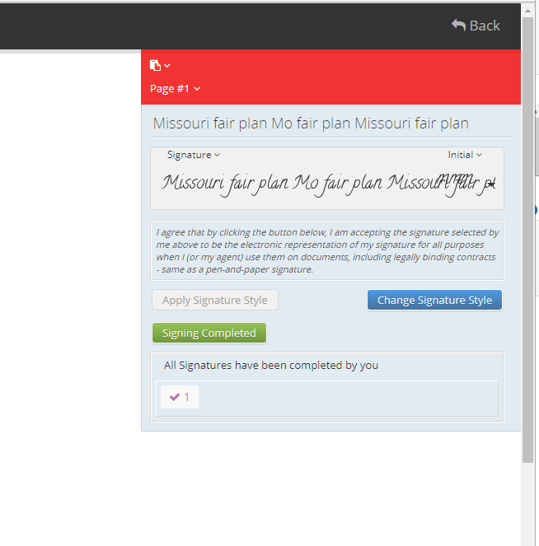
  - Signature will process. This may take a few minutes. It will circle and return to the main screen when finished.
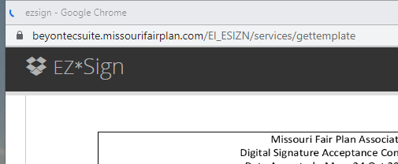
  - Signature will remain in the system for future use.

QUOTE ENTRY
- Dwelling and Sinkhole available to quote online.
  - Note: Commercial and Farm require applications to be submitted along with supplemental documents.
  - Commercial and Farm applications must be submitted via email to uw@mpipf.com or via fax or mail.
- Click “Quotes” on the left menu.
- From this menu – Start a new Sinkhole quick quote, Start a new Dwelling/Mobile Home quick quote, Search an Existing Quote or Search Referrals. Note: Referrals are those quotes that have been referred to underwriting for approval. Once approved you will be able to continue. If declined the reasons listed need to be resolved and information reentered as a new quote.
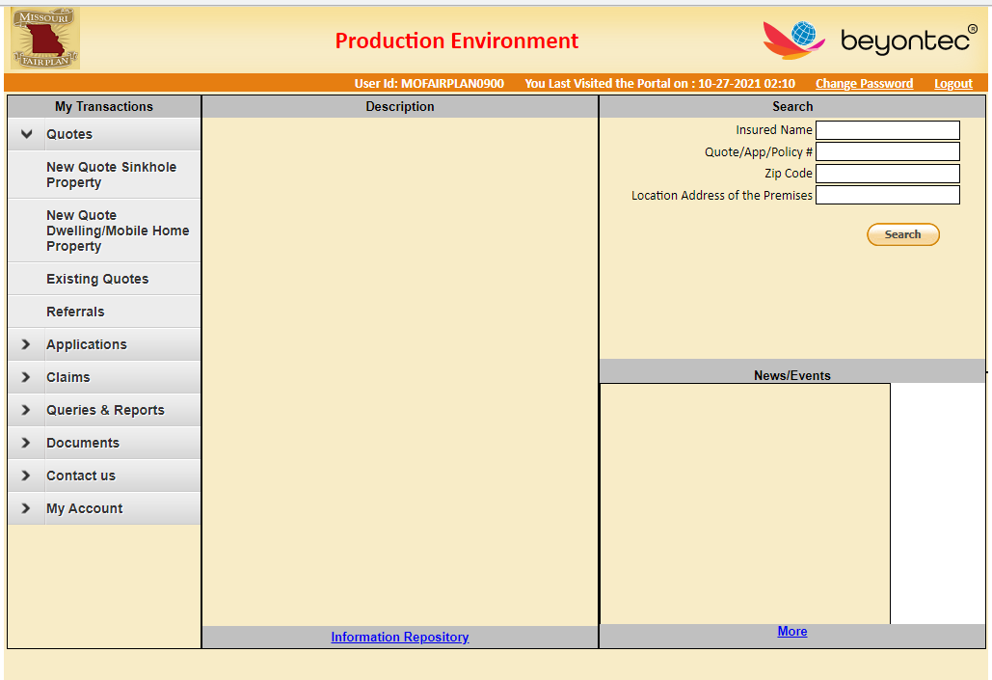

- Enter all data in caps (upper case) to ensure that declarations and forms print properly.
- All fields that highlight in red are required prior to getting a premium. Note: We encourage you to complete all fields to speed up the underwriting process and reduce additional questions.

CUSTOMER DETAIL PAGE – BASIC INFORMATION PAGE
– ENTER ALL DATA IN UPPER CASE
- Select individual or corporate button - The system will then open the correct name configuration to enter in the system.
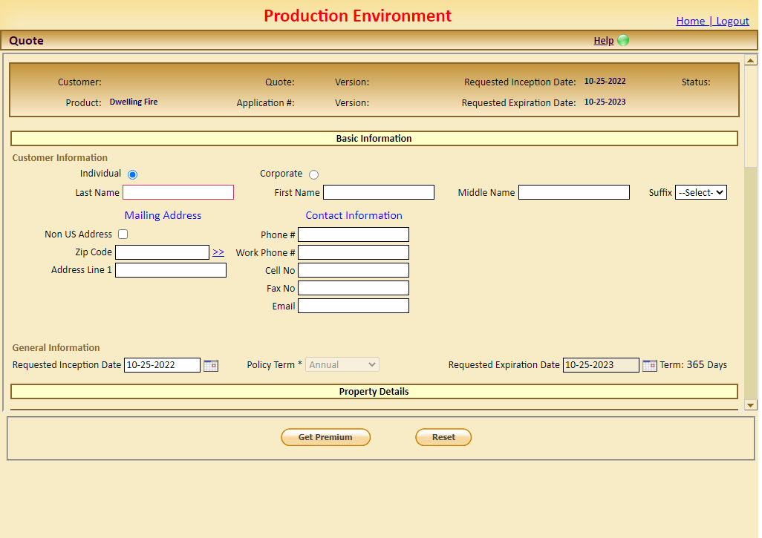
- Enter the individual or corporate name.
- Enter zip code for the mailing address. The system will access the USPS database to determine city and county based on the zip code. Click >> to expose entire address.
- Enter street address on Address line 1 only. Address 2 and 3 will not display on the printed forms.
- City and county should automatically populate from the zip code. If not, place curser in field and press space bar. This will allow you to select the city/county from available options.
- Read all messages in red as they will provide direction on what needs to be done to advance and get premium quote.
- Please complete all information that you can as it will be required later should you proceed to the full quote.
- Requested effective date will automatically populate as today’s date. A future date can also be used instead. We do NOT backdate, and system will NOT allow.

PROPERTY DETAILS – ENTER ALL DATA IN UPPER CASE
- Scroll down to property details section.
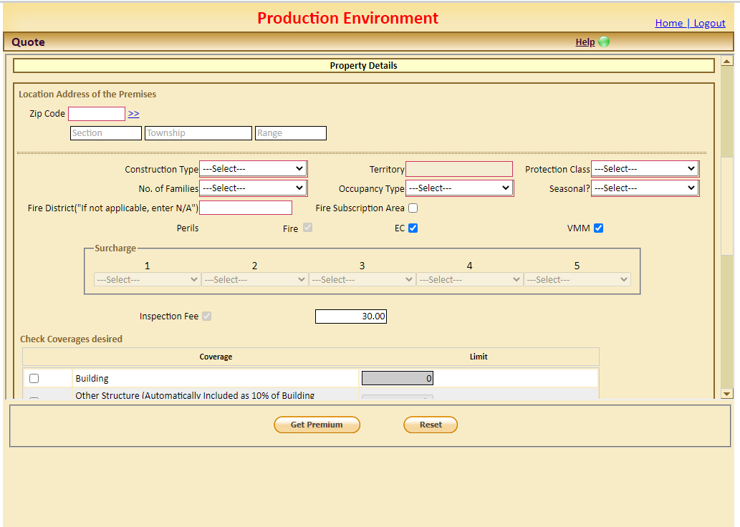
- Enter the location of property starting with zip code. This is the location of the property to be insured.
- Complete the remainder of the property location address the same way as mailing address.
  - Enter zip code for the mailing address. The system will access the USPS database to determine city and county based on the zip code. Click >> to expose entire address.
  - Enter street address on Address line 1 only. Address 2 and 3 will not display on the printed forms.
- Complete required underwriting information.
  - Construction, occupancy, and number of families. Note: The territory and protection class prefill from the address and number of families is determined by the number of kitchens.
- All perils are automatically checked. Note: Coverage options include - uncheck VMM or EC AND VMM. EC must be carried to have VMM.
- There is a $30 nonrefundable fee on all new policies for inspections. (Effective 11/1/2022 – increased from $25)

COVERAGE – ENTER ALL DATA IN UPPER CASE
- Scroll down in the property details to Check Coverages desired.
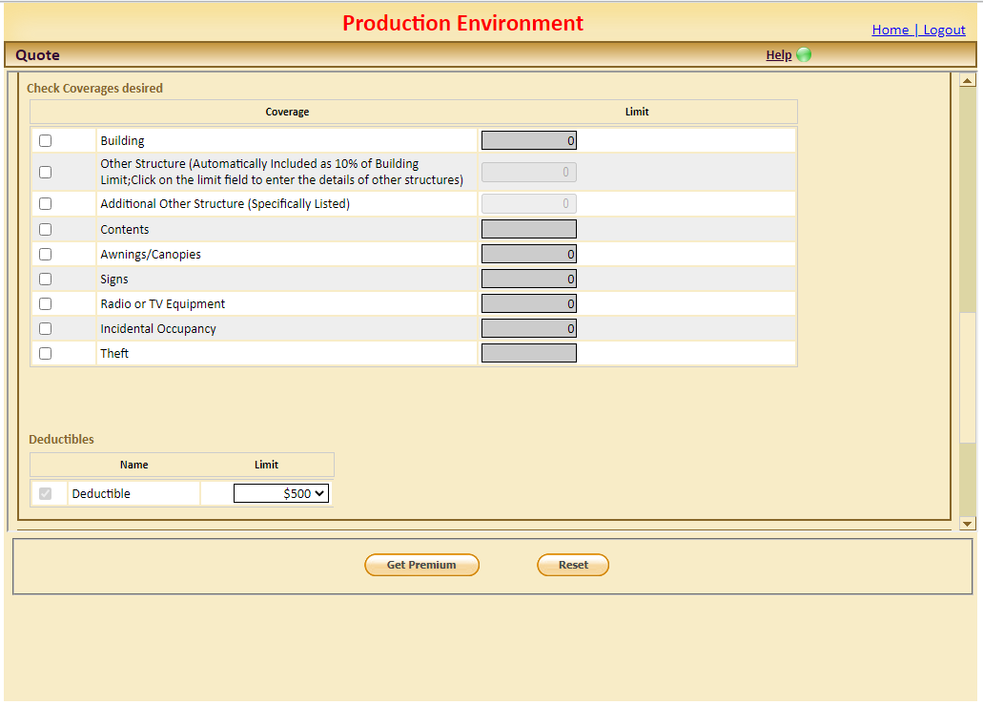
- Select the desired coverages and enter limits. Note: Maximum of $200,000 for total of all coverage limits.
- For other structures 10% or additional coverage you must click in the limit box which will then bring up the Other Structures detail box. Select the type of structure and indicate the condition of each.
- Please select and complete the Incidental occupancies option. These are service type occupancies like daycare or lawn mower repair that are done out of a residence.
- Please select Theft and input the limit if this coverage is desired. Theft is a separate limit from contents and is available from $1,000-$25,000 in thousand-dollar increments. Note: Contents with EC and VMM must be carried to be eligible for theft coverage.
- Select deductible that is desired. Note: $500 is the standard deductible standard.

QUESTIONS – ENTER ALL DATA IN UPPER CASE
- Scroll down to the Questionnaire section.
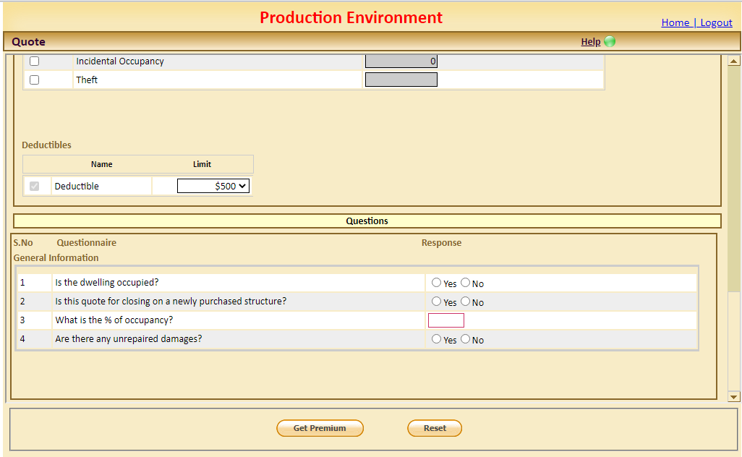
- Complete the General information questions. Note: Property must be 50% occupied or system will decline. If there are unrepaired damages system will refer quote to UW for approval before providing quote.
- Click Get Premium.
- The system will issue a QQ number at the top of the page along with the STATUS of the quote. Note: The status changes as the information progresses through underwriting.

ADDITIONAL INFORMATION

- Payment Options - If the premium is over $250 and not escrowed you can click “choose pay plan” for installment options.
- Print Quote – To complete the quote, submit the signed application, photos and driving directions for rural properties. The estimated premium must be submitted to bind coverage. Note: Acceptance is subject to approval by the Missouri FAIR Plan. Coverage is not guaranteed.
- Notes – Are for underwriting purposes and not available to the agents.
- Additional Information – If the agent needs to provide additional information or explanation, please send an email to underwriting at UW@MPIPF.COM .
- Additional Quote Options – If you want various quote options you can change your data fields and click GET PREMIUM and system will recalculate.
- Reset – If you click RESET the information is removed and you can start over with a new property.

ATTACHMENTS – ENTER ALL DATA IN UPPER CASE

- Click the upload Documents button.
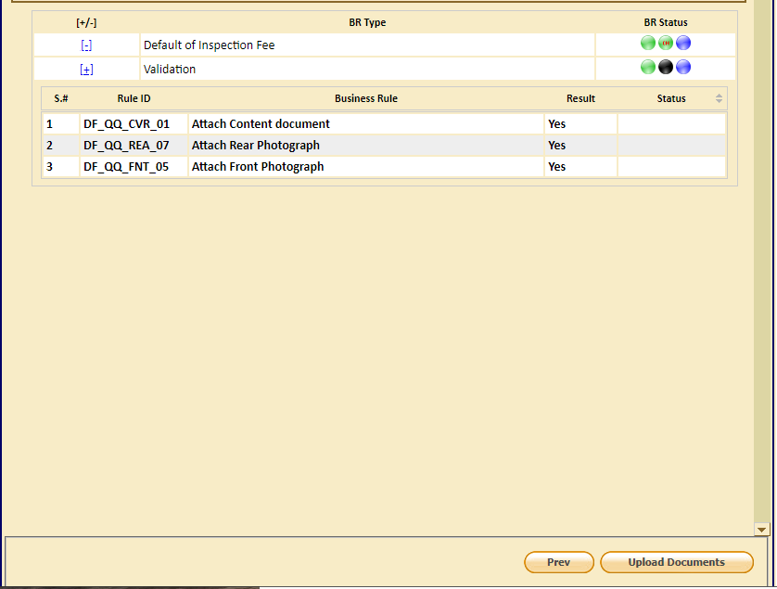
- Document Details
  - Documents are required to be uploaded.
  - Clear photos of the front and rear of the building are required.
  - Content photos or list and other structure photos are preferred if coverages are requested.
- Right click, on the hyper link, Insured and click edit.
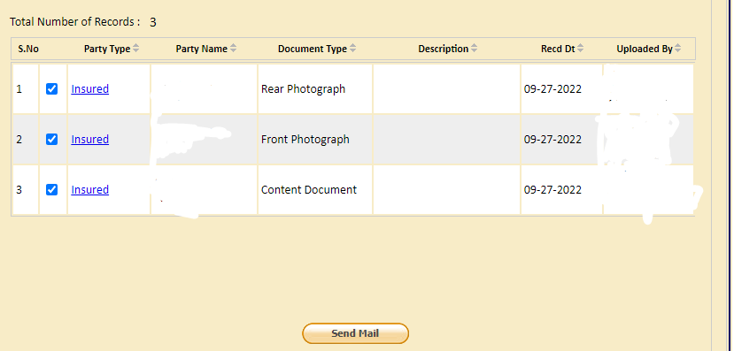
- Drag and drop or upload the documents from your computer.
- Next, click save and repeat process.
- If you have additional photos, use Select drop down menu and click new attachment.
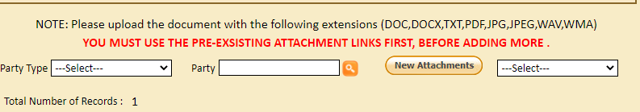
- Enter the Document type and a brief description before attaching the photo or document.
- When the documents correctly upload the Document Type hyper link will turn blue.
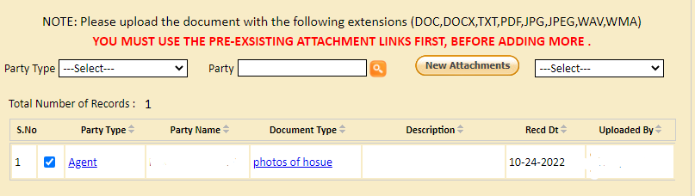
- Once all photos and documents are uploaded – Click, Confirm/Next.
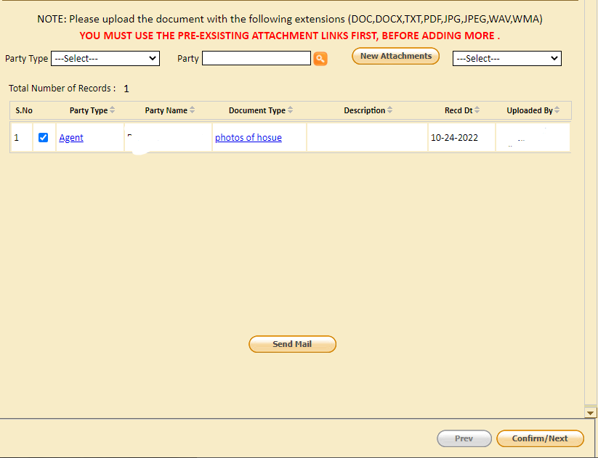
- Premium & Coverage Summary screen populates. Review for confirm correct coverages and limits are requested. You can also print a copy of the application from this screen for your records.
- Click Confirm/Next once information is validated.
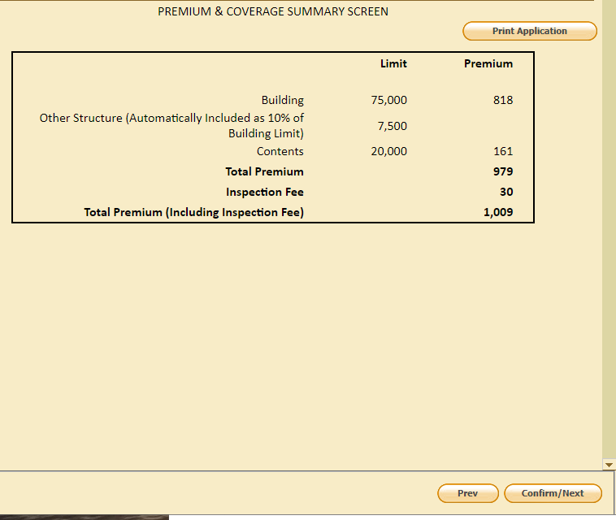
- Payor Screen populates. Select the premium Payor and Payment Plan. Note: Only Dwelling premiums more than $250 are eligible for installment option. Available installment option is 40 – 30 – 30 of premium. Escrowed / Mortgage Company accounts must be paid in full.
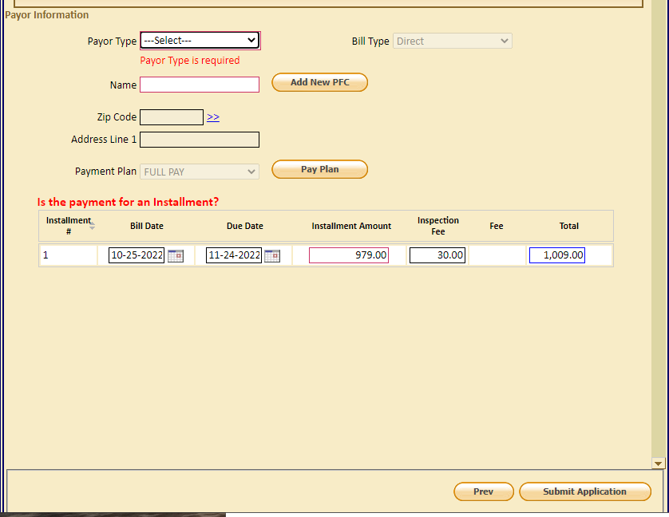

ELECTRONIC SIGNATURE
- Click Submit Application. Note: The application will NOT transfer to Missouri FAIR Plan until you click the Submit Application AND complete the electronic signatures for both the insured and agency.
- The system will proceed to the Print Package to Electronically sign the application.
- Click the hyper link, sign now for the insured signature.
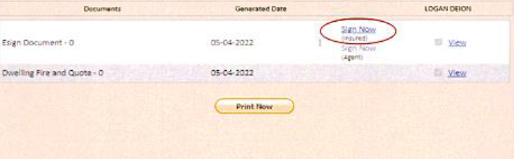
- Click the signature style from the dropdown menu on the right and select signature.
- Click apply signature style. Note: This is how the electronic signature will appear on the documents.
- Click start signature.
- Select “Click here to sign” on the left.
- Click Signing Completed.
- The system will return to the Print Package screen for the Producer’s signature.
- Click the hyper link Sign Now for the Producer Electronic Signature.
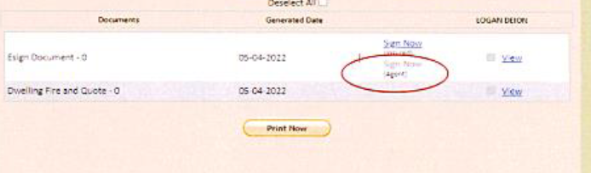
- You need only select start signature and click here to sign.
- Then Signing completed.
- The System will return to the Print Package screen. Note: The application still has NOT been submitted to underwriting.

SUBMIT APPLICATION
- Select the Payor Tab on the left.
- Click Submit Application.
- Click OK to submit the application to the underwriter on the confirmation box that pops up.
- The Status should change to WIP or Pending Approval.
- Make note of the Application number for future reference.

SINKHOLE– ENTER ALL DATA IN UPPER CASE
- Sinkhole quote entry follows the same screens and criteria as the dwelling entry.
  - Input all data in upper case
  - Complete all data - red fields are mandatory
  - Attach signatures and photos.
- Note: Deductible is a percentage of the coverage and cannot be changed.

APPLICATIONS TAB
- This tab allows review of declined applications, existing applications, applications not converted to a policy and referrals to the Underwriter.
- By clicking each tab the system will take you to a list of those properties which you can search.
- Click home to return to the home page.

SEARCH TAB ON RIGHT
- Allows you to search by named insured, policy number, zip code or location of property. Note: The system requires the exact location as it appears on the policy.

CLAIMS
- Under this tab you can report a loss or view a reported loss.
- To report losses, enter policy number. System will give you the ability to select the correct policy number.
- Select policy number based on the date of loss and click search. Example the /R01 or /R02 will have different expiration dates.
- Your name will appear as producer, change notification method if necessary.
- If contact information is different than producer select << and enter alternate contact information.
- Select loss date and description.
- Click confirm next.
- Use drop down to select type of loss you are reporting.
- Answer all questions to the best of your ability.
- Click Confirm Next.
- System will provide you with the FNOL loss number make note.
- This will now populate at MFP who will set up claim and assign an adjuster.
- After the claim file has been set up you will be able to view the claim information by going to Reported loss and entering your FNOL number and clicking the orange search button.
- You will be able to advance thru the claim with the tabs on the left. You will NOT be allowed to view documents between the company and the adjuster.

QUERIES & REPORTS
- Queries & Reports allows the agency to view individual commission reports
  - Click Queries & Reports
  - Click on Report
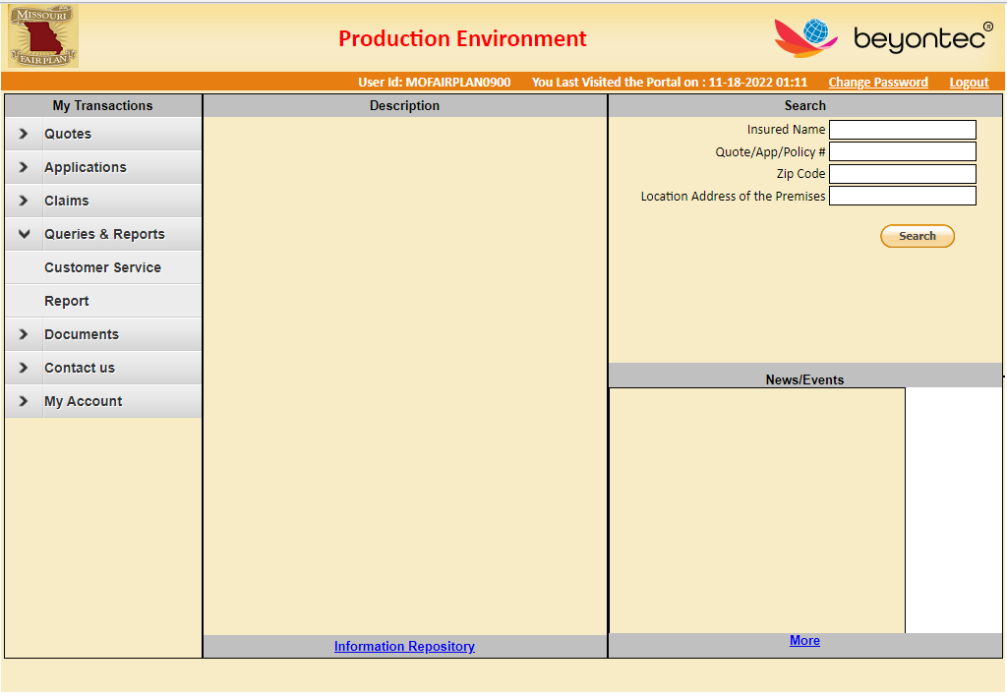
  - Click on Agent Commission Report
    - Enter the batch # in the Batch field displayed – the Batch # will always be the mm-yyyy of commission statement you want to view (Example: 07-2018)
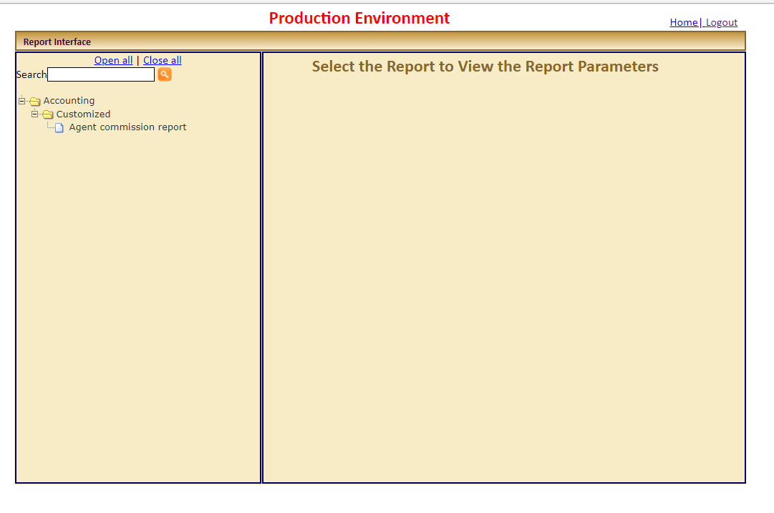
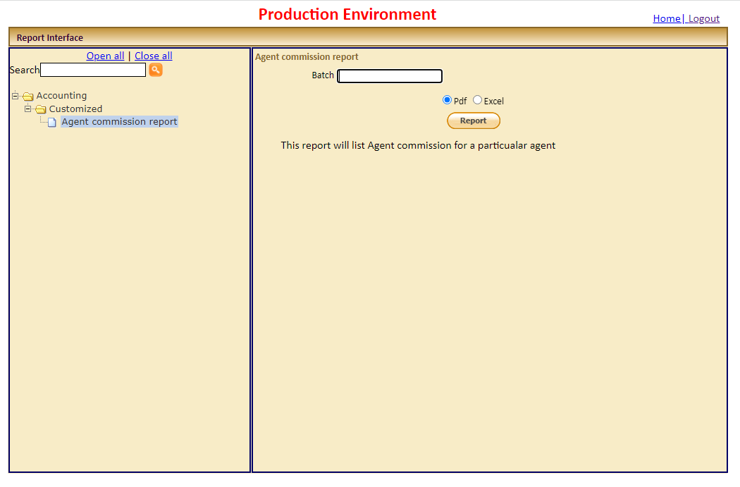
  - Click the “Report” button
  - The individual commission statement will be displayed.
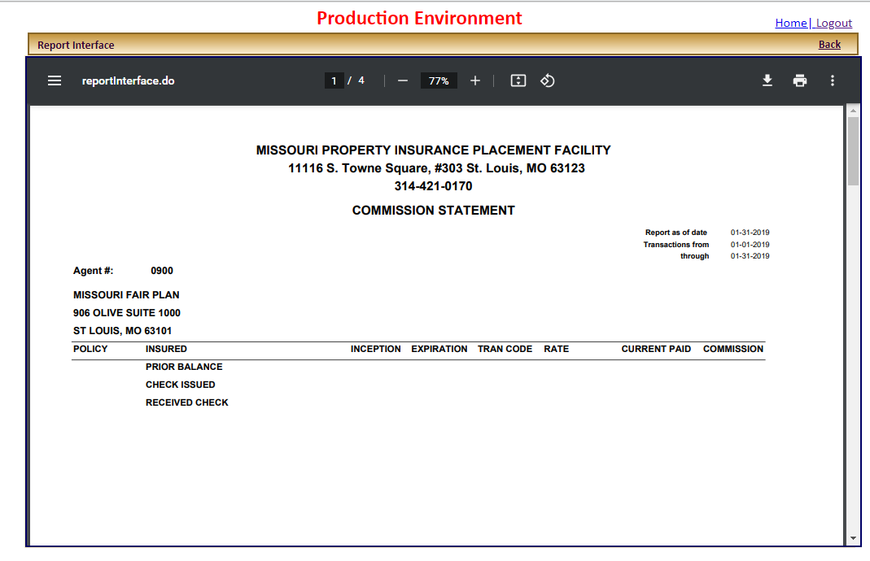

CONTACT US
- You will be able to locate our phone, fax, email and mailing address.

